Test Case: tc002_SPX_Dev5_Crear_Requisicion_Spot_Tipo_Cobro_Project
Step 1 - Enter username and password and click to button Enter: Credentials Entered
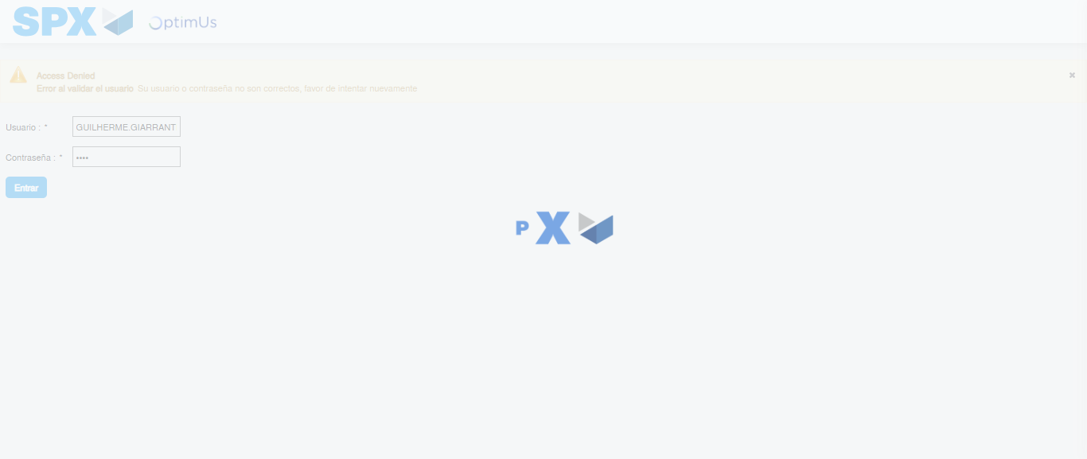Image file-name: QC_Testing-tc002_SPX_Dev5_Crear_Requisicion_Spot_Tipo_Cobro_Project-1784309172697

Step 2 - Select to UEN and Access to Spot Buy Requisitions : UEN Correctly selected and Correct access
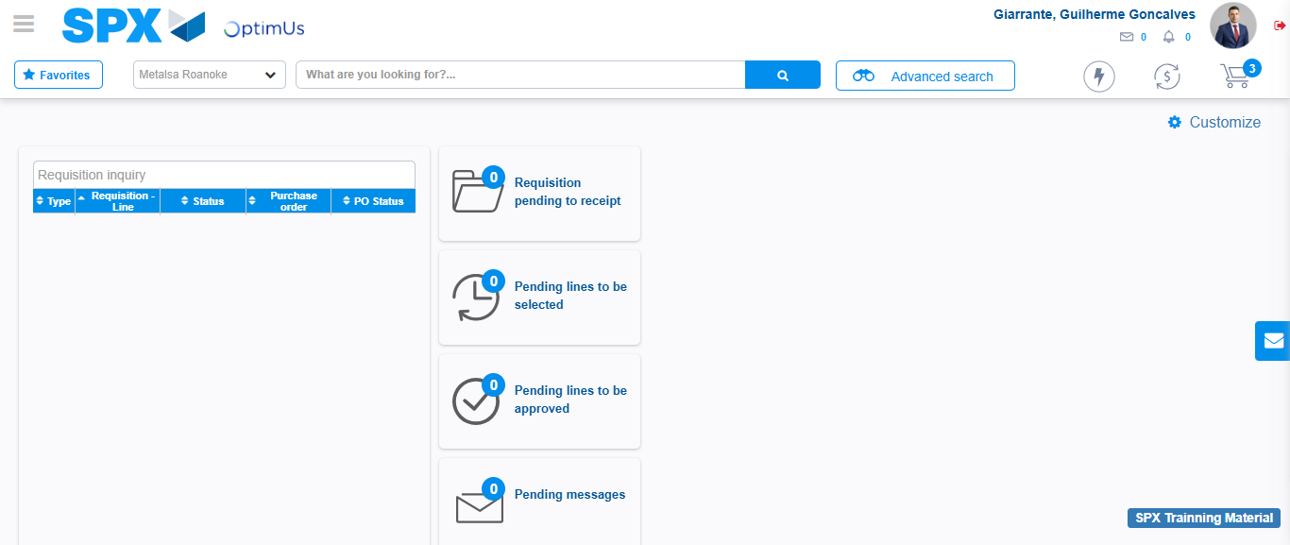Image file-name: QC_Testing-tc002_SPX_Dev5_Crear_Requisicion_Spot_Tipo_Cobro_Project-1784309204120

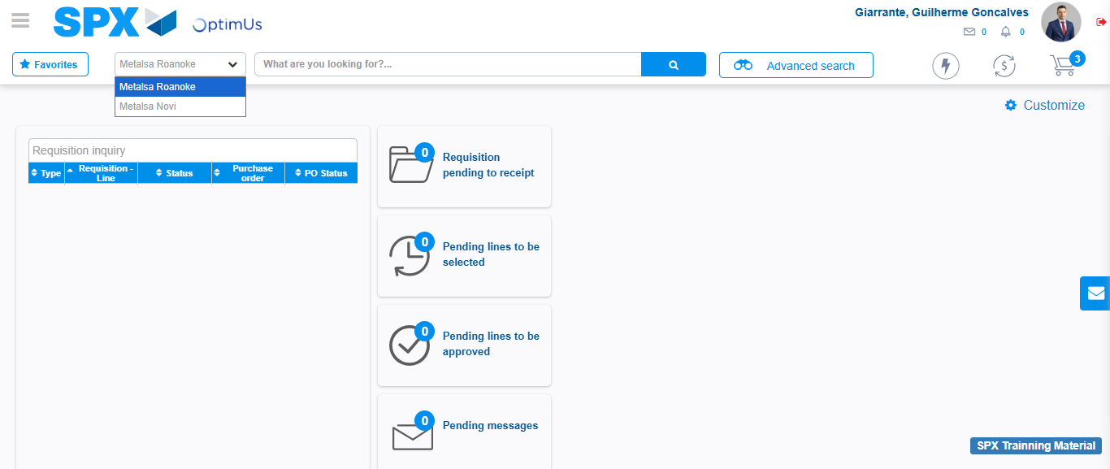Image file-name: QC_Testing-tc002_SPX_Dev5_Crear_Requisicion_Spot_Tipo_Cobro_Project-1784309206837

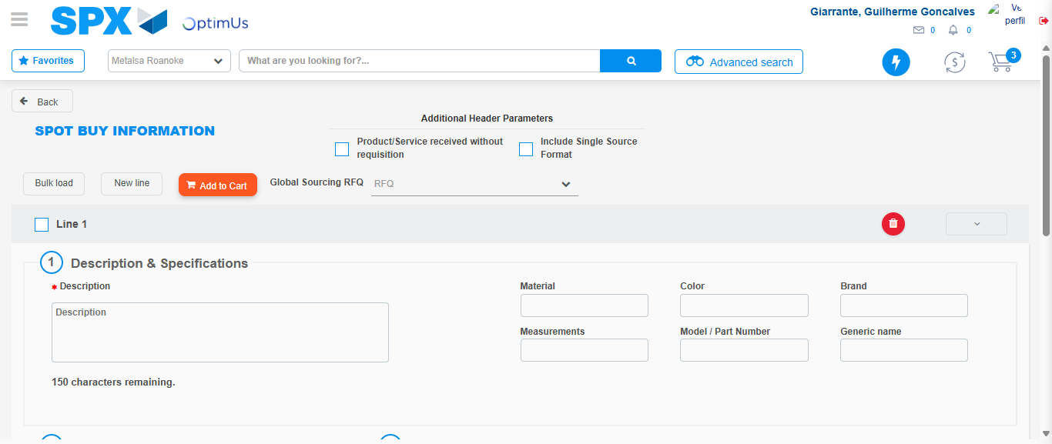Image file-name: QC_Testing-tc002_SPX_Dev5_Crear_Requisicion_Spot_Tipo_Cobro_Project-1784309230355

Step 3 - Data Capture Spot Buy Requisition: Data captured correctly
Image file-name: QC_Testing-tc002_SPX_Dev5_Crear_Requisicion_Spot_Tipo_Cobro_Project-1784309230649

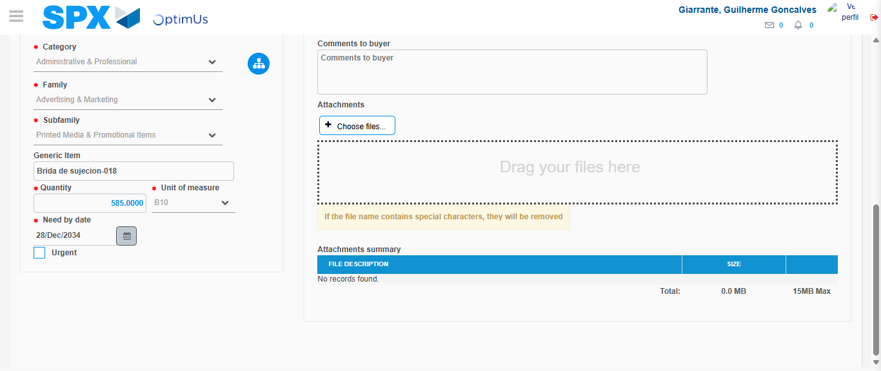Image file-name: QC_Testing-tc002_SPX_Dev5_Crear_Requisicion_Spot_Tipo_Cobro_Project-1784309244703

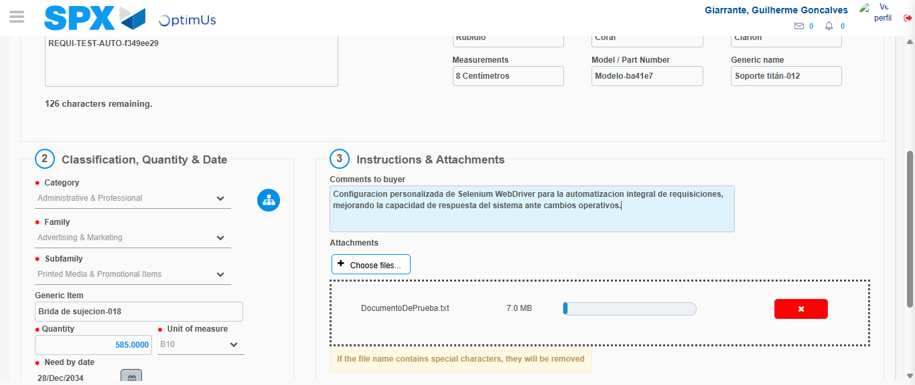Image file-name: QC_Testing-tc002_SPX_Dev5_Crear_Requisicion_Spot_Tipo_Cobro_Project-1784309245745

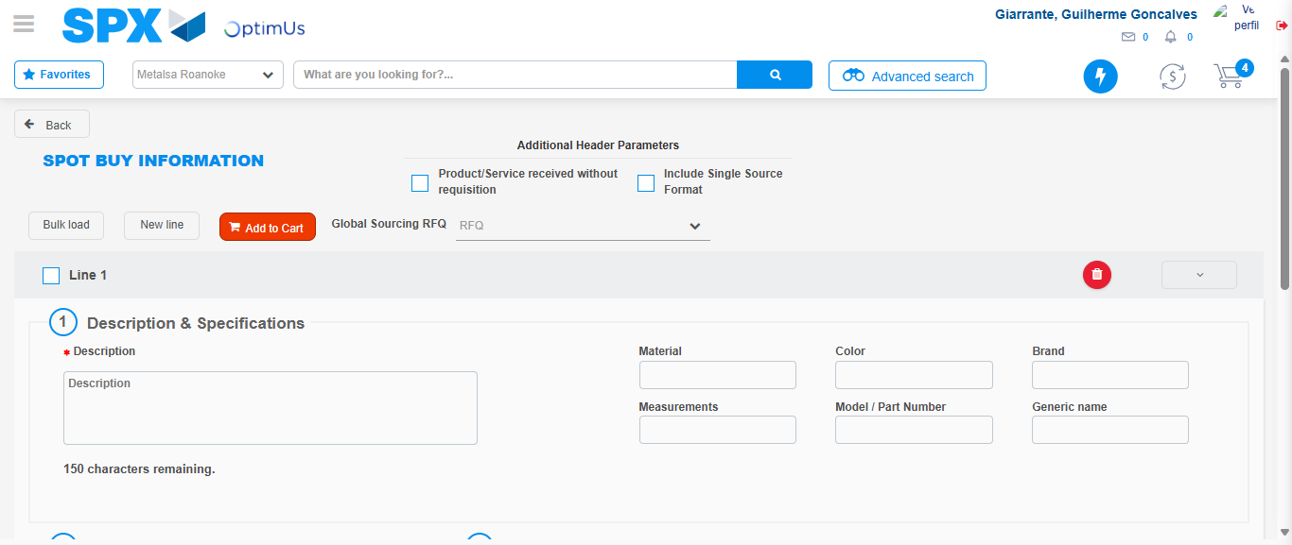Image file-name: QC_Testing-tc002_SPX_Dev5_Crear_Requisicion_Spot_Tipo_Cobro_Project-1784309251449

Step 7 - Return to Main Page SPX : Return to Main Page SPX
Image file-name: QC_Testing-tc002_SPX_Dev5_Crear_Requisicion_Spot_Tipo_Cobro_Project-1784309204120

Image file-name: QC_Testing-tc002_SPX_Dev5_Crear_Requisicion_Spot_Tipo_Cobro_Project-1784309206837

Image file-name: QC_Testing-tc002_SPX_Dev5_Crear_Requisicion_Spot_Tipo_Cobro_Project-1784309230355

Image file-name: QC_Testing-tc002_SPX_Dev5_Crear_Requisicion_Spot_Tipo_Cobro_Project-1784309253768

Image file-name: QC_Testing-tc002_SPX_Dev5_Crear_Requisicion_Spot_Tipo_Cobro_Project-1784309253972

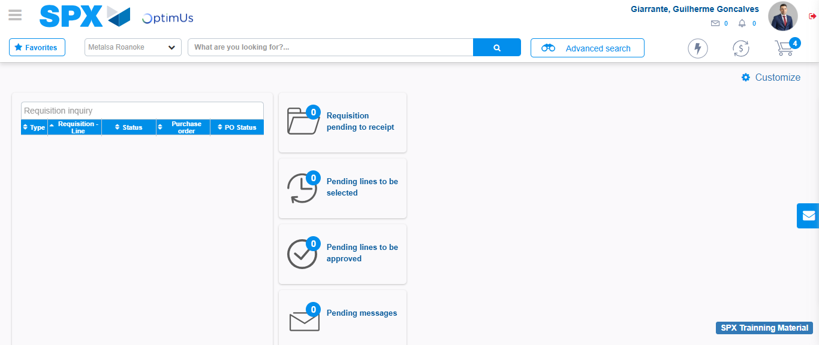Image file-name: QC_Testing-tc002_SPX_Dev5_Crear_Requisicion_Spot_Tipo_Cobro_Project-1784309275148

Step 8 - Log Out : Log Out SPX
Image file-name: QC_Testing-tc002_SPX_Dev5_Crear_Requisicion_Spot_Tipo_Cobro_Project-1784309275369

